A EL Project Synopsis on

**Online Voting System**

Submitted to Manipal University, Jaipur

Towards the partial fulfillment for the Award of the Degree of

**BACHELOR OF TECHNOLOGY**

In Computer and Communication Engineering

2021-2022

By

Name of the Candidates:

Sejal Balasaheb Shirsale & Vartika Paharia

Registration Numbers: 209303345 & 209303363 resp.



Under the guidance of

Mr. Jitendra Singh Yadav

Name of the Supervisor:

Mr. Jitendra Singh Yadav

**Department of Computer and Communication Engineering**

**School of Computing and Information Technology**

**Manipal University Jaipur**

**Jaipur, Rajasthan**

Project Title:

**ONLINE VOTING SYSTEM**

Team Members Registration numbers and Name:

Sejal Balasaheb Shirsale (209303345) & Vartika Paharia (209303363)

Introduction:

"ONLINE VOTING SYSTEM" refers to an online voting method. People with Indian citizenship who are over the age of 18 and of any gender can vote online without going to a physical polling station under this system. A database is kept in which all the names of voters with complete information are stored. A voter can use his or her voting right online without difficulty in the "ONLINE VOTING SYSTEM".

Objectives/Aim:

In the "Voting Rights Exercise System", voting rights can be exercised and voting rights can be exercised. To register yourself, you need to fill out the registration form. All entries are checked by a database that already contains all the information about the voters. If all entries are correct, the voter will receive a user ID and password that can be used to vote. If the condition is false, this entry will be discarded.

Methodology:

(Methodology will include the steps to be followed to achieve the objective of the project during the project development. Graph: Literature, Design, Implementation, Results and Conclusions, Report Writing)

Technical Details:

This project will be a Web application to be developed in PHP having

* Database Design (My SQL)
* Form Design (HTML 4.0) And CSS
* Coding (PHP)
* Testing (WAMP SERVER)
* Reporting Tool (Data Report)
* Web browsers: Mozilla Firefox, Google chrome, Opera and Internet.

1. Microsoft Windows with-

* Memory: 512 MB
* Disk space: 750 MB of free disk space

Market Potential & Competitive advantages:

* Service that is quick and simple.
* The online voting system is more time-efficient.
* It reduces paperwork and makes the job easier for the ELECTION COMMISSION.
* It is a more efficient method of voting.
* The voting percentage will skyrocket as a result of this.
* It is simple to use because voters do not need to go to a polling place.
* This framework will increment the voting rate in India.

Bibliography / References:

<http://www.wikipedia.com/>

ER DIAGRAM :

RELATIONAL SCHEMA :

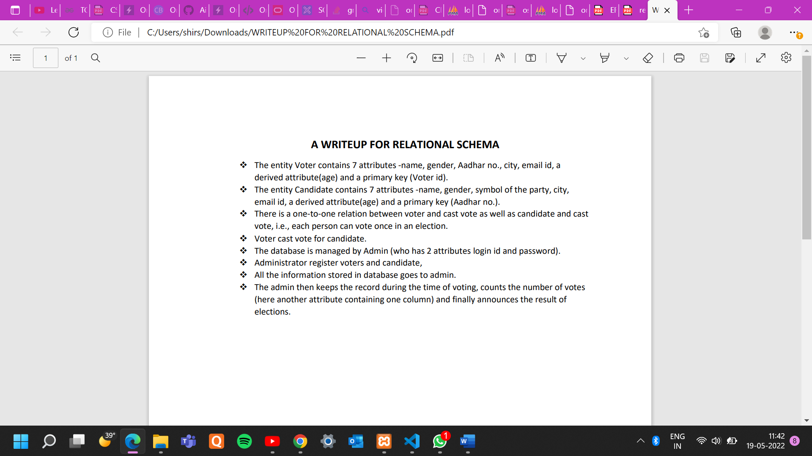

**RDBMS PROJECT:**

CREATE TABLE Voters (

voter_id varchar(255) NOT NULL,

email_id varchar(255),

name varchar(255),

gender varchar(255),

age int NOT NULL,

aadhar_number int NOT NULL,

city varchar(255),

PRIMARY KEY (voter_id)

);

CREATE TABLE candidate (

gender varchar(255) NOT NULL,

field_name varchar(255),

name varchar(255),

age int NOT NULL,

aadhar_number int NOT NULL,

symbol varchar(255),

city varchar(255),

email varchar(255),

PRIMARY KEY (aadhar_number)

);

CREATE TABLE admin (

login_id varchar(255) NOT NULL,

password varchar(255),

PRIMARY KEY (login_id)

);

CREATE TABLE result (

candidate_name varchar(255) NOT NULL,

symbol varchar(255),

PRIMARY KEY (candidate_name)

);

INSERT INTO voters (voter_id, email_id, name, gender, age,aadhar_number, city)

VALUES ('v101','a@abc.com','sejal','female','20','1234','jalgaon');

INSERT INTO voters (voter_id, email_id, name, gender, age,aadhar_number, city)

VALUES ('v102','b@abc.com','adamya','male','21','1256','jaipur');

INSERT INTO voters (voter_id, email_id, name, gender, age,aadhar_number, city)

VALUES ('v103','c@abc.com','ruttvik','male','90','1589','dehradun');

INSERT INTO voters (voter_id, email_id, name, gender, age,aadhar_number, city)

VALUES ('v104','d@abc.com','varnika','female','45','1379','mumbai');

INSERT INTO voters (voter_id, email_id, name, gender, age,aadhar_number, city)

VALUES ('v105','e@abc.com','atharva','male','55','1309','jalgaon');

INSERT INTO candidate (gender, name, age, aadhar_number, symbol, city, email_id)

VALUES ('male','varun','36','1052','hand','jaipur','e@abc.com');

INSERT INTO candidate (gender, name, age, aadhar_number, symbol, city, email_id)

VALUES ('female','garima','26','1946','lotus','jaipur','f@abc.com');

INSERT INTO candidate (gender, name, age, aadhar_number, symbol, city, email_id)

VALUES ('male','purvansh','100','1610','redtape','jaipur','g@abc.com');

INSERT INTO candidate (gender, name, age, aadhar_number, symbol, city, email_id)

VALUES ('female','aashima','40','1487','paisa','jaipur','h@abc.com');

INSERT INTO admin (login_id, password)

VALUES ('jitendra','muj1234');

INSERT INTO admin (login_id, password)

VALUES ('RAJ','muj123');

ALTER TABLE candidate

RENAME COLUMN email TO email_id;

ALTER TABLE candidate DROP column field_name;

**QUERIES :**

1} select * from voters order by voter_id asc;

3} select * from candidate;

4} select * from admin;

5} CREATE TRIGGER Check_age BEFORE INSERT ON voters

FOR EACH ROW

BEGIN

IF NEW.age < 18 THEN

SET MESSAGE_TEXT = 'ERROR:

AGE MUST BE ATLEAST 18 YEARS OR ABOVE!';

END IF;

END;

6} CREATE TRIGGER Check_cand_age

BEFORE INSERT ON candidate

FOR EACH ROW

BEGIN

IF NEW.age < 18 THEN

SET MESSAGE_TEXT = 'ERROR:

AGE MUST BE ATLEAST 18 YEARS OR ABOVE!';

END IF;

END;

7}  **create an after insert trigger for that :**

create trigger total_votes_count

after insert on voters

for each row

begin

if (new.value == 1) then

update posts set total_votes = total_votes+1

where id = new.id_post;

end if;

end;//

8}**For handling the update all remains same, only you need another trigger something as:**

create trigger total_votes_count_upd after update on voters

for each row

begin

if (new.value == 1) then

update posts set total_votes = total_votes+1

where id = new.id_post;

elseif (new.value == -1) then

update posts set total_votes = total_votes-1

where id = new.id_post;

end if;

end;//

9} CREATE TRIGGER Count_tupples

AFTER INSERT ON employee

FOR EACH ROW

BEGIN

SET count = count + 1;

END;

10} SELECT MAX(count(*))

FROM candidate GROUP BY name;

